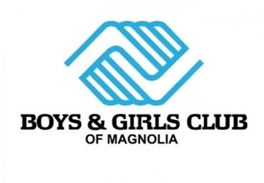

Derrick Berry Jr Memorial Scholarship Application

Name: _____________________________________________

Address: ___________________________________________

Age: ______________________________________________

Current School: _____________________________________

College planning on attending: ________________________

Years Involved with Boys & Girls Club of Magnolia: ___________

Please give details in your/current involvement with Boys & Girls Club of Magnolia:

_________________________________________________________________________________________

_________________________________________________________________________________________

_________________________________________________________________________________________

_________________________________________________________________________________________

_________________________________________________________________________________________

Why I applied for this scholarship?

________________________________________________________________________________________

________________________________________________________________________________________

________________________________________________________________________________________

________________________________________________________________________________________

Derrick Berry Jr Memorial Scholarship Application

Scholarship Paperwork Required:

- Current headshot picture of scholarship applicant

- Current copy of latest high school transcript

- 2 letters of recommendation ( 1 personal recommendation and 1 from community member)

- 3 completed essays which must be 2 page with minimum of 750 words

- My Club Experience

- Why Community Service Matters to You

- Your experience overcoming adversity

Applications must be received by April 30, 2026.

Please return all required scholarship application material to:

Chris Ludwig
Chief Executive Officer
Boys & Girls Club of Magnolia
cludwig.bgcm@gmail.com

1600 Hollensworth
Magnolia, AR 71753
870-299-3341 cell
870-234-3300

